Regulatory Committee
Meeting to be held on 23rd June 2021

Part I

Electoral Division affected:
Lancaster Rural North

Wildlife and Countryside Act 1981
Definitive Map Modification Order Investigation
Addition of Bridleway along Lord's Lot Road, Over Kellet
(Annex ‘A’ refers)

Contact for further information quoting ref. 804-642:
Simon Moore, 01772 531280, Paralegal Officer, County Secretary and Solicitors Group, Simon.Moore@lancashire.gov.uk
Jayne Elliott, 01772 537663, Public Rights of Way Definitive Map Officer, Planning and Environment Group, jayne.elliott@lancashire.gov.uk

Executive Summary

Application for the addition of a Bridleway along Lord's Lot Road, Over Kellet, Lancaster.

Recommendation

That the application for the addition of a Bridleway along Lord's Lot Road,

Over Kellet be accepted with amendment.

That an Order be made pursuant to Section 53 (2)(b) and Section 53 (3)(c)(i)

of the Wildlife and Countryside Act 1981 to add to the Definitive Map and Statement of Public Rights of Way a Bridleway along Lord's Lot Road, Over Kellet as shown on Committee Plan between points A-W-X.

That being satisfied that the higher test for confirmation can be met the Order

be promoted to confirmation.

Background

An application under Schedule 14 of the Wildlife and Countryside Act 1981 has been received for the addition to the Definitive Map and Statement of Public Rights of Way of a Bridleway along Lord's Lot Road, Over Kellet between points A-W-H on the Committee plan. This is referred to in this report as the 'application route' and the similar route A-W-X joining Borwick Road a little further south as the 'amended route'.

The county council is required by law to investigate the evidence and make a decision based on that evidence as to whether a public right of way exists, and if so its status. Section 53(3)(b) and (c) of the Wildlife and Countryside Act 1981 set out the tests that need to be met when reaching a decision; also current Case Law needs to be applied.

An order will only be made to add a public right of way to the Definitive Map and Statement if the evidence shows that:
- A right of way “subsists” or is “reasonably alleged to subsist”

An order for adding a way to or upgrading a way shown on the Definitive Map and Statement will be made if the evidence shows that:
- “the expiration… of any period such that the enjoyment by the public…raises a presumption that the way has been dedicated as a public path or restricted byway”

When considering evidence, if it is shown that a highway existed then highway rights continue to exist (“once a highway, always a highway”) even if a route has since become disused or obstructed unless a legal order stopping up or diverting the rights has been made. Section 53 of the Wildlife and Countryside Act 1981 makes it clear that considerations such as suitability, the security of properties and the wishes of adjacent landowners cannot be considered. The Planning Inspectorate’s website also gives guidance about the interpretation of evidence.

The county council’s decision will be based on the interpretation of the evidence discovered by officers and documents and other evidence supplied by the applicant, landowners, consultees and other interested parties produced to the County Council before the date of the decision. Each piece of evidence will be tested and the evidence overall weighed on the balance of probabilities. It is possible that the council’s decision may be different from the status given in any original application. The decision may be that the routes have public rights as a footpath, bridleway, restricted byway or byway open to all traffic, or that no such right of way exists. The decision may also be that the routes to be added or deleted vary in length or location from those that were originally considered.

Consultations

Lancaster City Council

Lancaster City Council did not provide a response to our consultation.

Over Kellet Parish Council

Over Kellet Parish Council responded in support of the application; "Over Kellet Parish Council supports the application for the addition of a Public Bridleway along Lord's Lot Road, Over Kellet. Councillors do have some concerns about the condition of the route, especially during the Winter months and would seek reassurance from the County Council that, should the DMMO be approved, the road surface is adequately maintained."

Applicant/Landowners/Supporters/Objectors

The evidence submitted by the applicant/landowners/supporters/objectors and observations on those comments are included in Advice – Head of Service – Legal and Democratic Services Observations.

Advice

Head of Service – Planning and Environment

Points annotated on the attached Committee plan.

Point | Grid Reference (SD) | Description
A | 5340 6978 | Open junction with Kirby Lonsdale Road
B | 5350 7015 | Kissing gate in fence bounding application route providing access to woodland (designated as Access Land)
C | 5359 7029 | Further kissing gate in fence bounding application route providing access to woodland (designated as Access Land)
D | 5368 7053 | Bend in application route and vehicular access point to fields north of route
E | 5384 7061 | Vehicular access to field to north of application route
F | 5396 7064 | Metal barrier across application route with gap to side
G | 5473 7080 | Metal barrier across application route with gap to side
H | 5474 7081 | Open junction of current Lord's Lot Road with Borwick Road
W | 5473 7077 | Bend on application route where modern day route and historical route diverge
X | 5476 7078 | Historical junction (no longer in existence) of Lord's Lot Road with Borwick Road

Description of Route

A site inspection was carried out in September 2020.

The application route commences at the junction with Kirby Lonsdale Road (B6254) at point A from where it extends in a generally northerly and then north north easterly direction along a stone surfaced track bounded by a stone wall to the west and a hedge/fencing to the east. The surfaced road is approximately 3-4 metres wide and is capable of being used by walkers, cyclists, horse riders and vehicles.

No signage is present at point A to indicate whether use of the route is considered to be public or private and access onto the route is unrestricted at this point.

At point B a kissing gate exists in the fence separating the application route from the woodland to the east. The kissing gate provides pedestrian access into the woodland which is designated as Access Land and on the day that the route was inspected a car was seen to drive up the application route and to park close to point B from where the driver left the car and was seen taking several dogs for a walk into the woodland via the kissing gate at point B.

From point B the application route continues in a north north easterly direction along the stone surface road bounded on both sides. A further kissing gate provides access into the woodland at point C.

From point C vehicular access is available to the fields north and west of the application route and as the application route turns (point D) to continue in a more north easterly direction it appears to be used less frequently by vehicles and whilst the roadway is still surfaced with compacted stone a grass strip exists down the centre.

At point E there is access from the application route to what appears to be an area used to contain livestock north of the route. From this point onwards there appears to be little or no use of the route with vehicles and although there still appears to be an obvious stone base to the route the surface has largely become grassed over and is quite boggy underfoot in a number of places. The route continues in a generally easterly direction for a short distance to a locked metal barrier (point F). This has been erected across the route to prevent vehicles wider than the gap around the side of the barrier. This bypass allows walkers, cyclists and horse riders to pass and would also be wide enough for motorbikes and quad bikes. A Forestry Commission sign is attached to the barrier specifically forbidding use of motorbikes and quadbikes from the route.

Beyond point F the application route continues along the northern boundary of the woodland in a generally easterly direction, the surface is boggy at first but improves as it enters the woodland and continues as an unbounded track rising gently uphill towards Borwick Road. There is a bend in the track (point W) where the amended route leaves the application route but is no longer visible on the ground. Just before joining the road the application route is crossed by a further metal barrier (at point G) which is identical to the one located at point F. Again, there is a gap alongside the barrier which would allow access on foot, horseback and bicycle and Forestry Commission signage specifically stating that motorbikes and quad bikes were forbidden from using the route. An old stone gatepost was also in existence close to point G.

From point G the application route continues a further 10 metres along a stone surfaced track to meet Borwick Road at point H.

The amended route diverges from the application route at point W and runs east through the trees to meet Borwick Road (point X) 25m south of the current access (point H).

The total length of the application route (points A-W-H) is approximately 1.95 kilometres, as is that of the amended route.

Map and Documentary Evidence

A variety of maps, plans and other documents were examined to discover when the route came into being, and to try to determine what its status may be.

Document Title | Date | Brief Description of Document & Nature of Evidence
Yates’ Map  of Lancashire | 1786 | Small-scale commercial map. Such maps were on sale to the public and hence to be of use to their customers the routes shown had to be available for the public to use. However, they were privately produced without a known system of consultation or checking. Limitations of scale also limited the routes that could be shown.
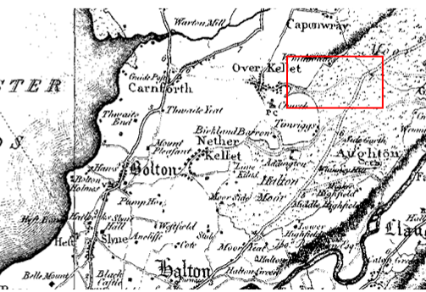
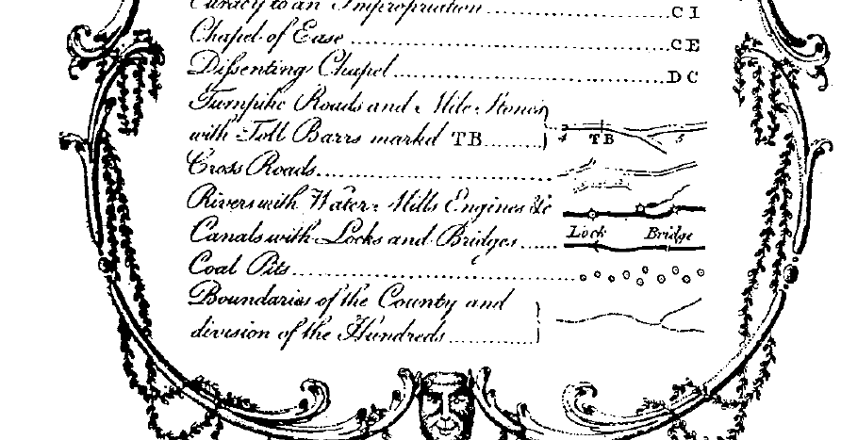

Observations |  | A route is shown extending east from Over Kellet across an area of moorland connecting to the road to Kirby Lonsdale (B6254) but this does not appear to be part of the application route.
Investigating Officer's Comments |  | The application route is not shown. It may have been that the application route did not physically exist in 1786 or possibly that Yates did not consider the route to be a vehicular highway or possibly that this section was not surveyed, as surveys were expensive. No inference can be drawn.
Over Kellet Inclosure Act Award and Maps  CRO Ref: AE/5/9 | 1805 | Inclosure Awards are legal documents made under private acts of Parliament or general acts (post 1801) for reforming medieval farming practices, and also enabled new rights of way layouts in a parish to be made. They can provide conclusive evidence of status.  Over Kellet Moor was enclosed by a private act of parliament dated 1779 (volume 2). The Inclosure Award is available to view at the CRO (Ref: AE/5/9) and is dated 1805.
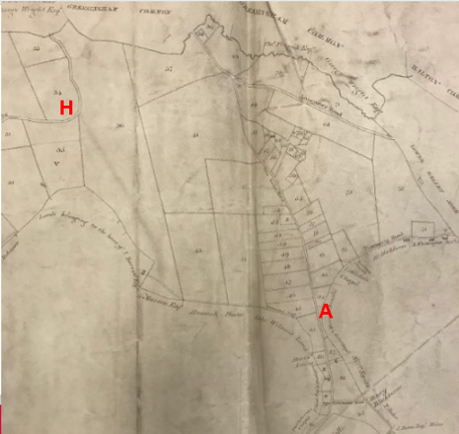

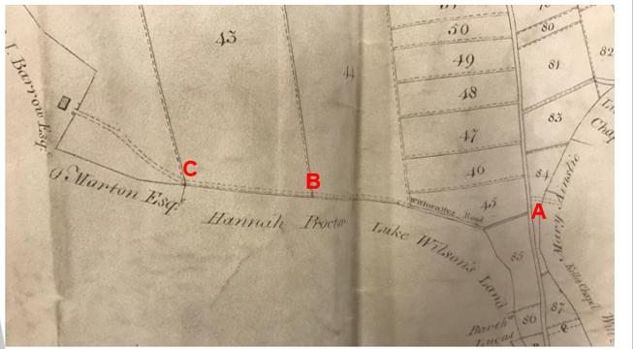
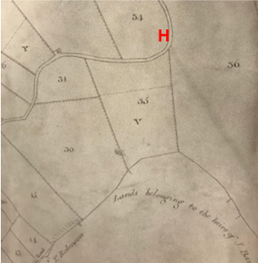

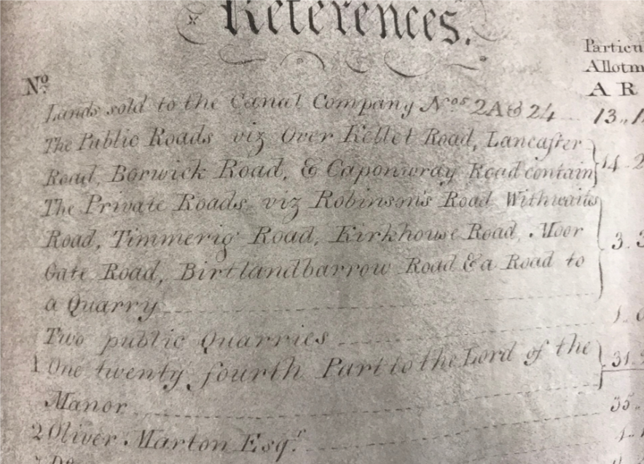

Observations |  | The Inclosure Award map covers the area over which the application route runs. Whilst most of the application route is not shown the start of the route from point A to point C is shown consistent with the application route which provides access to a building. The route is labelled as Withwaites Road and stated to be a private road in the key to the map. The rest of the application route is not shown.
Investigating Officer's Comments |  | A route largely consistent with the application route from point A extending for approximately 390 meters appears to have been acknowledged – or possibly created - as part of the inclosure process as access to an unnamed building. It is named on the map and specified as being a private road. The rest of the application or amended route is not shown and does not appear to have existed at that time.
Greenwood’s Map of Lancashire | 1818 | Small-scale commercial map. In contrast to other map makers of the era Greenwood stated in the legend that this map showed private as well as public roads and the two were not differentiated in the key panel.
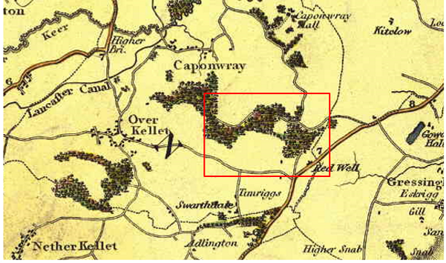

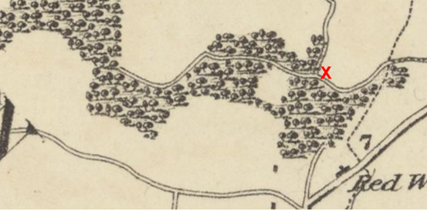
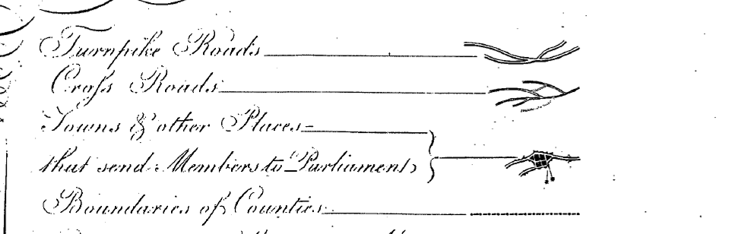
Observations |  | A road is shown passing through woodland from point X, in a westerly direction consistent with the amended route but a through route to point A is not shown (including the route shown on the Inclosure Award map from point A passing through points B and C.)
Investigating Officer's Comments |  | At least part of the route existed in 1818 but is not shown as a through route. The fact that only part of the route is shown on such a small-scale map is not inconsistent with the existence of bridleway rights but no inference can be drawn with regards to the existence of a through route.
Hennet's Map of Lancashire | 1830 | Small-scale commercial map. In 1830 Henry Teesdale of London published George Hennet's Map of Lancashire surveyed in 1828-1829 at a scale of 7½ inches to 1 mile. Hennet's finer hachuring was no more successful than Greenwood's in portraying Lancashire's hills and valleys but his mapping of the county's communications network was generally considered to be the clearest and most helpful that had yet been achieved.
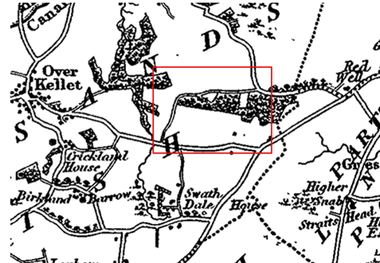
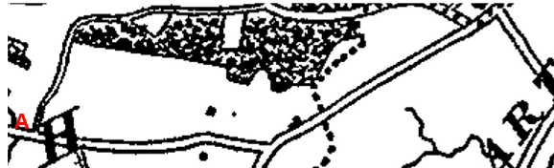
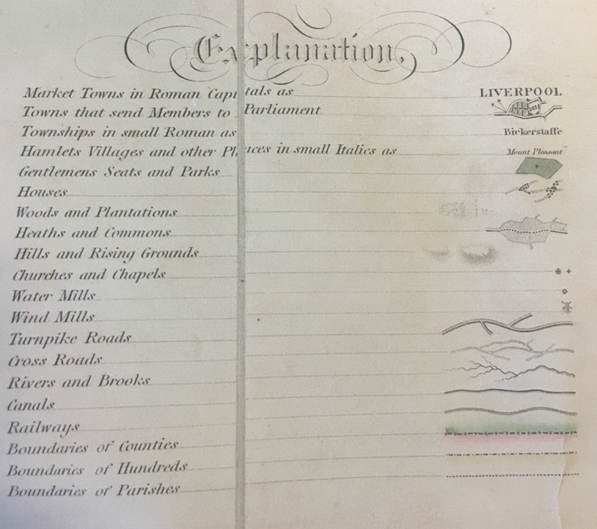
Observations |  | The full length of the amended route is shown as a 'cross road' but appears narrower – particularly at point A than the public vehicular highway that it connects to. The application route between W-G-H is not shown.
Investigating Officer's Comments |  | The amended route existed in 1830 and is shown as a 'cross road'. It is not fully known what is meant by this term. As the only other category of 'road' shown on the map are turnpike roads, it is possible that a cross road was regarded as either a public minor cart road or a bridleway (as suggested by the judge in Hollins v Oldham).  Hollins v Oldham Manchester High Court (1995) [C94/0205] Judge Howarth examined various maps from 1777-1830 including Greenwoods, Bryants and Burdetts. Maps of this type, which showed cross roads and turnpikes, were maps for the benefit of wealthy people and were very expensive. There was “no point showing a road to a purchaser if he did not have the right to use it.”  It is unlikely that a map of this scale would show footpaths and it is considered likely that Hennet's map shows routes depicted as through routes that were generally available to the travelling public in carts or on horseback and therefore suggests that by inclusion on the map the route was considered to be a public bridleway or carriageway in 1830.
Canal and Railway Acts |  | Canals and railways were the vital infrastructure for a modernising economy and hence, like motorways and high-speed rail links today, legislation enabled these to be built by compulsion where agreement couldn't be reached. It was important to get the details right by making provision for any public rights of way to avoid objections but not to provide expensive crossings unless they really were public rights of way. This information is also often available for proposed canals and railways which were never built.
Observations |  | There are no existing, dismantled or known proposals for canals or railways across the land over which the application route runs.
Investigating Officer's Comments |  | No inference can be drawn.
Over Kellet Tithe Map and Tithe Award or Apportionment | 1847 | Maps and other documents were produced under the Tithe Commutation Act of 1836 to record land capable of producing a crop and what each landowner should pay in lieu of tithes to the church. The maps are usually detailed large scale maps of a parish and while they were not produced specifically to show roads or public rights of way, the maps do show roads quite accurately and can provide useful supporting evidence (in conjunction with the written Tithe Award) and additional information from which the status of ways may be inferred.
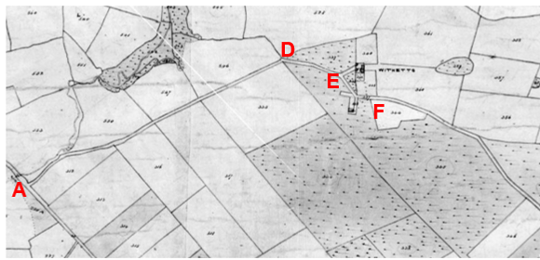
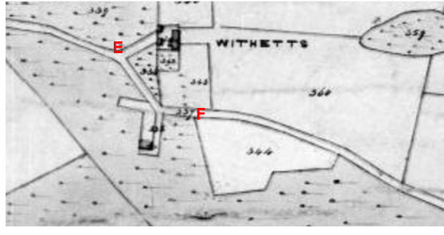

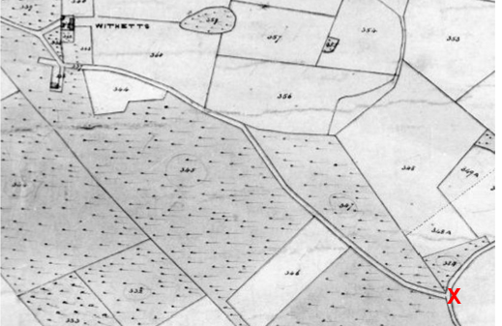
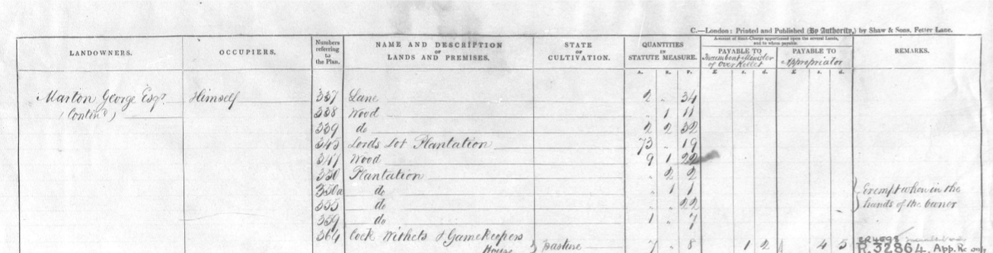
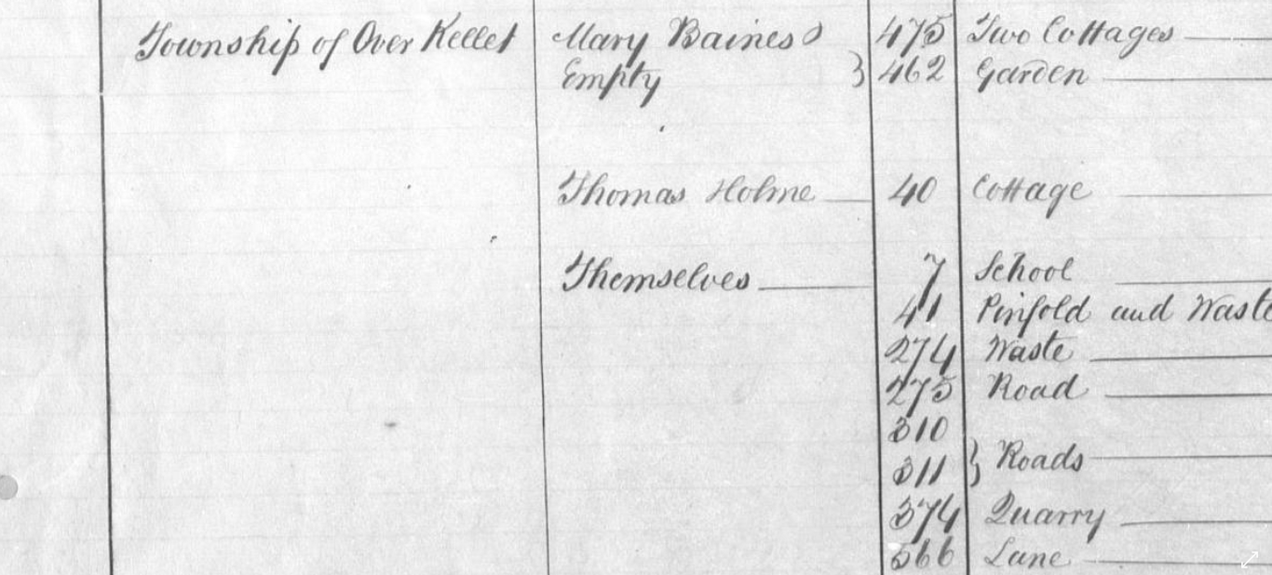
Observations |  | The full length of the amended route is shown as a bounded route connecting to roads now recorded as public vehicular carriageways. No gates are shown across the route and access from the route is shown to two properties midway along it (between point E and point F).  One number is shown on the plan along the route – located close to the entrances to the two properties mentioned above and located midway along the application route between point E and point F. The number – 337 – is listed in the Tithe Award as being land owned and occupied by George Marton. It is described as a 'lane' with a measurement listed but no state of cultivation and no tithe payable.  Whilst difficult to read, Kirby Lonsdale Road appears to be numbered 311 which is listed in the Tithe Award as being a road in the Township of Over Kellett with the inference that it, and several others listed with it, were public roads through the parish.  The building shown on the Inclosure Award Map is not shown and there is no reference to a private road named Withwaite Road (as named in the Inclosure Award).
Investigating Officer's Comments |  | The amended route existed as a through route in 1847. It provided access to two properties but was also shown as a through route – not just as a route to and from the properties. No lines (gates) are shown across the route suggesting that it would have been accessible in the 1840s.  The Investigating Officer was of the view that the whole route appears to have been described in the Tithe Award as part of parcel 337 which was listed as a lane but which was owned and occupied by a private landowner as opposed to being listed as one of the roads 'owned' by Over Kellet Township. This suggests, that whilst the route may have been accessible it was not considered to be part of the public vehicular highway network at that time. It may however have been used on horseback – and possibly horse drawn vehicles and certainly appeared to be wide enough to accommodate such use.
6 Inch Ordnance Survey  Sheet 25 | 1847 | The earliest Ordnance Survey (OS) 6 inch map for this area surveyed in 1844-45 and published in 1847.
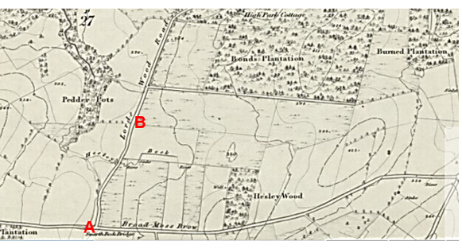

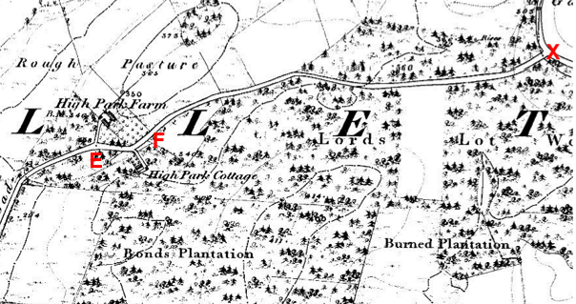
Observations |  | The full length of the amended route is shown as a bounded route connecting at either end to public vehicular highways. It passes through woodland known as Lord's Lot Wood and provides access to two properties – High Park Farm and High Park Cottage – both of which are accessed from midway along the route (between point E and point F). The route is labelled as 'Lords Wood Road' and no lines are shown across it suggesting that it was not gated. The width of the route is shown consistent with other routes over which there is a public right of access with vehicles.
Investigating Officer's Comments |  | The amended route existed as a substantial named through route which appeared capable of being used in 1844-45.  It is considered that a substantial bounded route providing access to and past a number of properties and connecting to a network of other public highways would have been at least a public bridleway and may have carried public vehicular rights.
Cassini Map Old Series  Sheet 97  Kendal and Morecambe | 1852-1865 | The Cassini publishing company produced maps based on Ordnance Survey mapping. These maps have been enlarged and reproduced to match the modern day 1:50,000 OS Landranger Maps and are readily available to purchase.
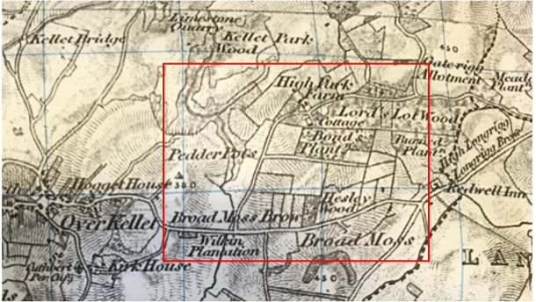
Observations |  | The full length of the amended route is shown as a substantial bounded route passing through the woodland and providing access to named properties.
Investigating Officer's Comments |  | The original scale of the map (1 inch to the mile) means that only the more significant routes are generally shown. The early (first edition) OS maps on which the Cassini Old Series maps were based were originally produced for military purposes in case they were needed for defence. The inclusion of the route on those maps suggests that a substantial route existed which probably could have been used by all traffic but we do not know if that use was public or private.
25 Inch OS Map  Map Sheets XXV.5 and XXV.6 | 1891 | The earliest OS map at a scale of 25 inch to the mile. Surveyed in 1890 and published in 1891.
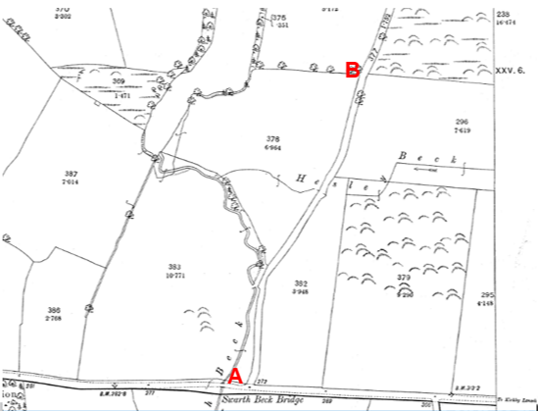
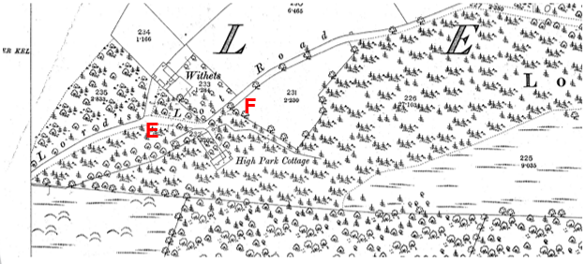

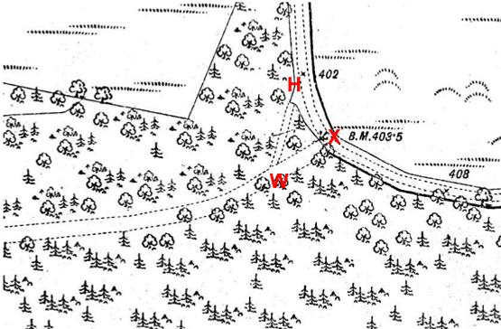
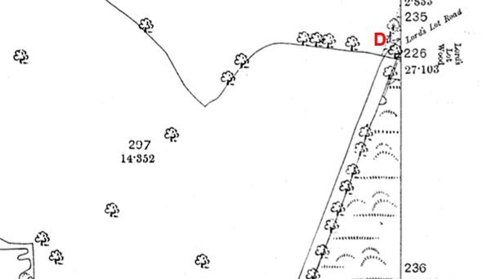

Observations |  | The full length of the application and amended route is shown and is named on the map as Lord's Lot Road.  The two properties situated part way along the route (between point E and point F) are shown but the property to the north of the route is now named 'Withets' not High Park Farm. Both properties are shown as being accessed from the application route with access into both gated.  The route is shown as being partly bounded on either or both sides but through the woodland east of point F through to points G and X it is bounded by dashed lines along most of its length suggesting the existence of an unenclosed track through the wood. A line is shown across the end of each route at points G and X suggesting that the exit onto Borwick Road was gated.  Both Kirby Lonsdale Road and Borwick Road are shown with thickened lines along the south and east sides but the application route is not.  A further line – indicating the existence of a gate - is shown across the route at point D (on the eastern edge of OS map sheet XXV.5) with separate parcel numbers and acreage listed for the route from point A to the gate (parcel number 377) and from the gate to point G and X (parcel number 227).
Investigating Officer's Comments |  | The application and amended route existed as a substantial named through route which appeared to be capable of being used on horseback and with horse drawn vehicles in 1891 although it looks to have been gated at two locations at that time.  The existence of gates along a public route would not have been considered unusual in the 1800s particularly in the proximity of farms or in rural locations. Gateways, if they were found to exist, were shown by the surveyor in their closed position although this is not necessarily a true reflection of what may have been the position on the ground.  The Planning Inspectorate Consistency Guide states "Public roads depicted on 1:2500 maps will invariably have a dedicated parcel number and acreage." However, it goes on to say that this is far from conclusive evidence of highway status and in this particular case two parcel numbers are listed split by a gate part way along the route.  The fact that the route is named as a road on the map is evidence that it was known locally by that name and is consistent with use of the route by the public at least on horseback at that time although it is noted that the First Edition 6 inch OS named it as Lords Wood Road as opposed to the First Edition 25 inch map published over 50 years later where the name was recorded as Lord's Lot Road.  The fact that the route is not shown with a thickened line to one side on the black and white edition of the map in the way that Kirby Lonsdale Road and Borwick Road are shown suggests that the application route was not considered to be a publicly maintained vehicular road at that time. Shading and colouring were often used to show the administrative status of roads on 25 inch maps prepared between 1884 and 1912. The Ordnance Survey specified that all metalled public roads for wheeled traffic kept in good repair by the highway authority were to be shaded and shown with thickened lines on the south and east sides of the road. 'Good repair' meant that it should be possible to drive carriages and light carts over them at a trot. The fact that the route was not shown in this way is consistent with how it appeared to be recorded in the Tithe Award and that whilst it was probably passable by horse drawn vehicles – particularly as it provided access to properties – it may not have been considered to be a public road at that time. The way it is shown on the map is not, however, inconsistent with use of the route by the public at least on horseback.
6 inch OS Map  Sheet XXV | 1894 | 6 inch OS map surveyed 1890 and published 1894.
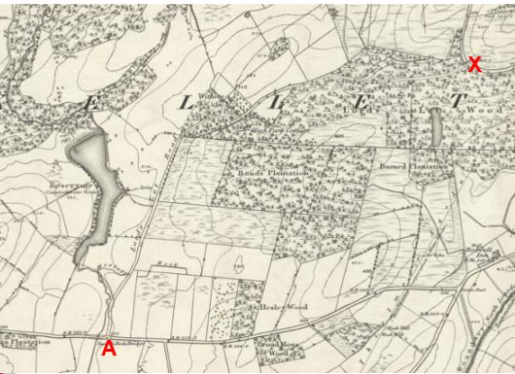

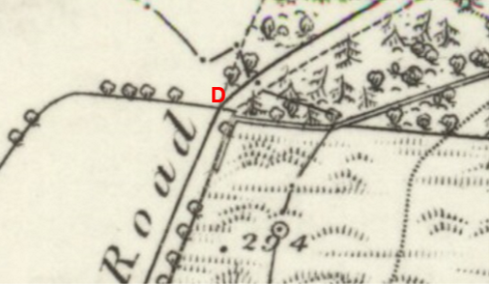
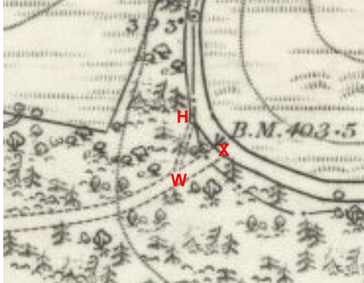
Observations |  | The full length of the application and amended route is shown as a substantial bounded route passing as an unenclosed track through the woodland and providing access to named properties. Lines are shown across the route at points D, G and X.
Investigating Officer's Comments |  | The application and amended route existed as a substantial named through route which appeared capable of being used in 1894.  It is considered that a substantial route providing access to and past a number of properties and connecting to a network of other public highways is consistent with a way which carried at least a public bridleway and may have carried public vehicular rights.
1 inch OS Map  Sheet 59 - Lancaster | 1898 | Small-scale Ordnance Survey map surveyed 1842-48, revised 1896 and published 1898.
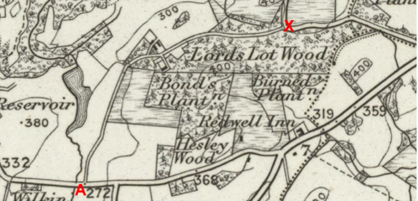
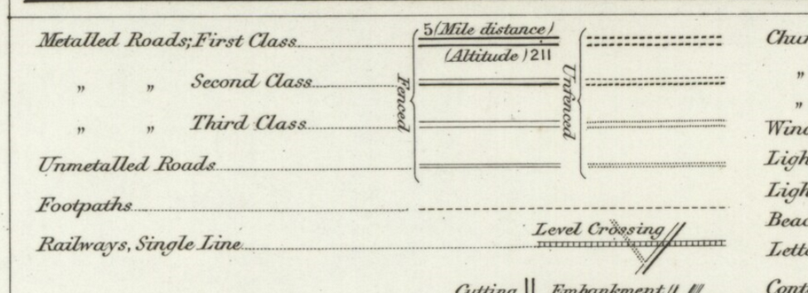
Observations |  | The full length of the amended route, but not that part W-G of the application route, is shown as an enclosed through route providing access to properties midway along it. It appears to be depicted on the map as a third class road or unmetalled road. There are no lines across the route at either end but there is one near point D, presumably a gate. There are no other such gates shown on the other roads nearby.
Investigating Officer's Comments |  | This is a map surveyed to show what existed physically. The existence of this substantial road does not in itself show public rights but is consistent with public rights supported by other evidence.  By the late 1800s the small scale 1 inch OS maps had started to gain a significant market being the travelling public so the inclusion of most of the route on this map is suggestive of a route that was capable of being used at least on horseback and possibly by horse and carts.
25 inch OS Map  Sheets XXV.5 and XXV.6 | 1913 | Further Edition of the 25 inch map surveyed in 1890, revised in 1910 and published in 1913.
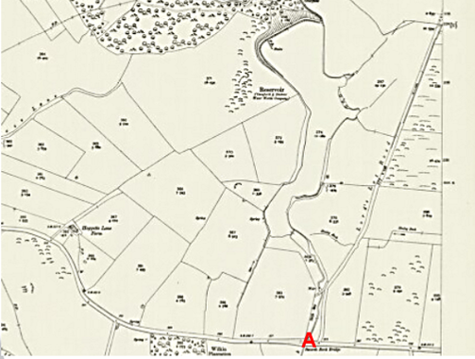

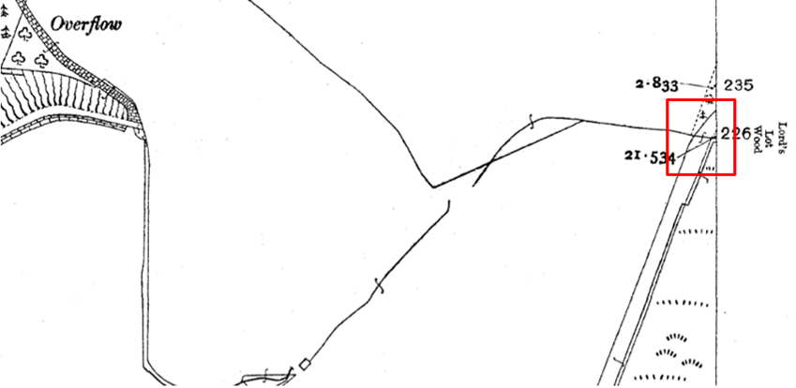
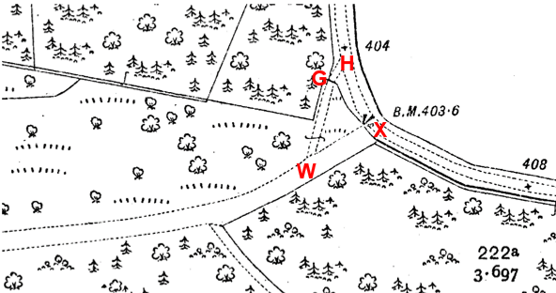
Observations |  | The full length of the application and amended route is shown, enclosed or unenclosed, and named as Lord's Lot Road. A gate is shown across the route at point G and X but what looked to have been shown as a gate at point D on the First Edition 25 inch map now looks to be shown not as a gate but as a watercourse which crossed the application route and which fed into a reservoir to the west.
Investigating Officer's Comments |  | The application and amended route existed as a substantial named through route in 1910 and appeared capable of being used.
6 inch OS map  Sheet XXV.NW | 1916 | 6 inch OS map revised 1910-11 and published in 1916.
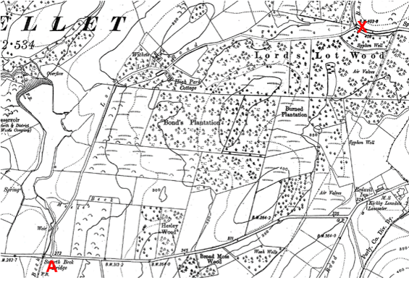

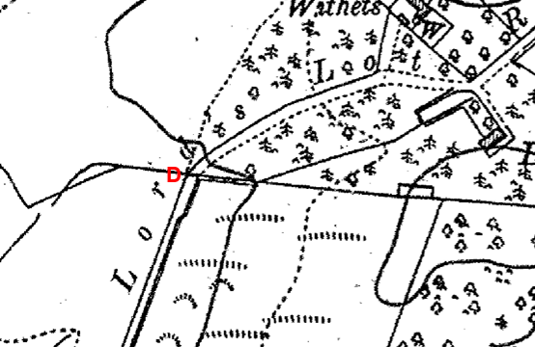

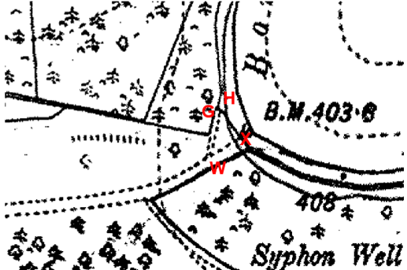
Observations |  | The full length of the application and amended route is shown as a part enclosed / part unenclosed route connecting at either end to public vehicular highways. It passes through woodland known as Lord's Lot Wood and provides access to two properties – Withets and High Park Cottage – both of which are accessed from midway along the route (between point E and point F). The application route is labelled as "Lord's Lot Road". Lines are shown across it at points D, G and X suggesting the existence of gates although the 25 inch OS map prepared around the same dates shows the route at point D crossed by a watercourse. (It is not unusual that a ditch and field boundary would follow the same line). The width of the route is shown consistent with use with vehicles. Two exit/access points are again shown onto Borwick Road – both appear to have been gated – with the amended route to X, south of point H shown to be wider than the application route.
Investigating Officer's Comments |  | The application and amended route existed as a substantial named through route in 1910 and appeared capable of being used.
Bartholomew half inch Mapping | 1905-1941 | The publication of Bartholomew's half inch maps for England and Wales began in 1897 and continued with periodic revisions until 1975. The maps were very popular with the public and sold in their millions, due largely to their accurate road classification and the use of layer colouring to depict contours. The maps were produced primarily for the purpose of driving and cycling and the firm was in competition with the Ordnance Survey, from whose maps Bartholomew's were reduced. An unpublished Ordnance Survey report dated 1914 acknowledged that the road classification on the OS small-scale map was inferior to Bartholomew at that time for the use of motorists.
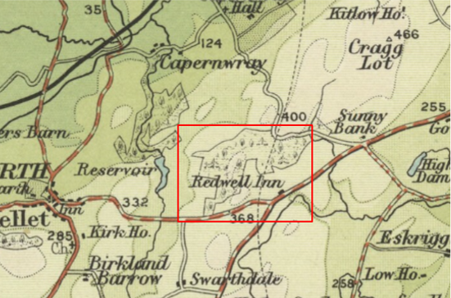
Sheet 5 - North Lancashire and Isle of Man – published 1905
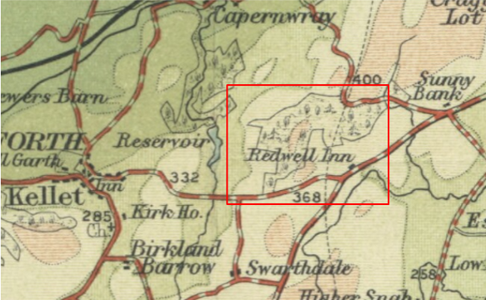
Sheet 5 – North Lancashire and Isle of Man – published 1920
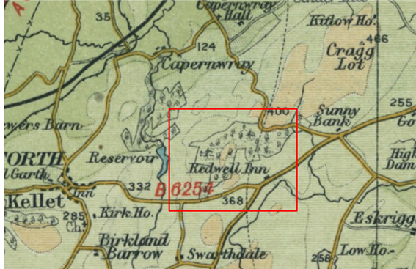
Sheet 31 – North Lancashire – published 1941
Observations |  | The route is not shown on any of the three editions of Bartholomew's maps.
Investigating Officer's Comments |  | OS maps dated before and after the publication of Bartholomew's Maps confirm the physical existence of the route over this period. As they were derived from the Ordnance Survey maps which probably showed it, Lord's Lot Road may have been purposely omitted by Bartholomew so the fact that the route is not shown on any of the three maps inspected suggests that it was not considered to be a public vehicular road at that time.
Finance Act 1910 Map | 1910 | The comprehensive survey carried out for the Finance Act 1910, later repealed, was for the purposes of land valuation not recording public rights of way but can often provide very good evidence. Making a false claim for a deduction was an offence although a deduction did not have to be claimed so although there was a financial incentive a public right of way did not have to be admitted.  Maps, valuation books and field books produced under the requirements of the 1910 Finance Act have been examined. The Act required all land in private ownership to be recorded so that it could be valued and the owner taxed on any incremental value if the land was subsequently sold. The maps show land divided into parcels on which tax was levied, and accompanying valuation books provide details of the value of each parcel of land, along with the name of the owner and tenant (where applicable).  An owner of land could claim a reduction in tax if his land was crossed by a public right of way and this can be found in the relevant valuation book. However, the exact route of the right of way was not recorded in the book or on the accompanying map. Where only one path was shown by the Ordnance Survey through the landholding, it is likely that the path shown is the one referred to, but we cannot be certain. In the case where many paths are shown, it is not possible to know which path or paths the valuation book entry refers to. It should also be noted that if no reduction was claimed this does not necessarily mean that no right of way existed.
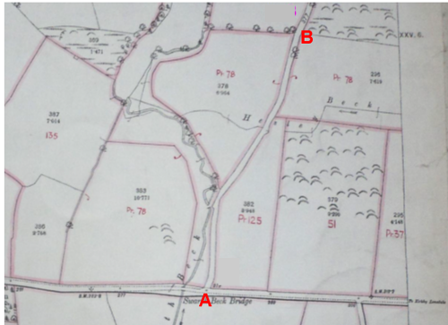
Map deposited in The National Archives
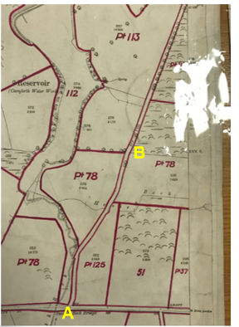
Map deposited in the County Archives
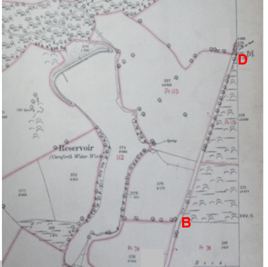
Map deposited in The National Archives
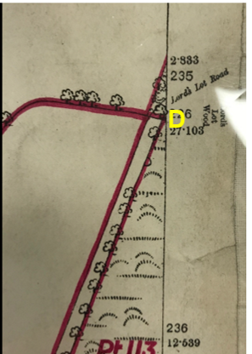
Map deposited in the County Archives

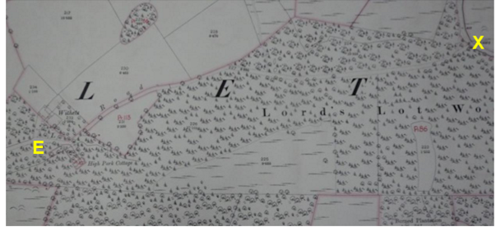
Map deposited in the National Archives
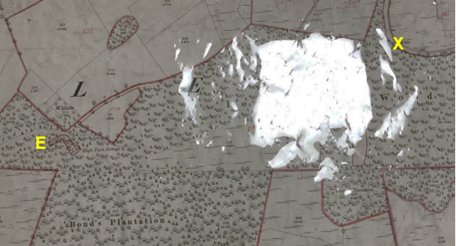

Map obtained from the County Archives
Observations |  | The quality of the Finance Act map extracts available from photographs taken at The National Archives are quite poor. However, the maps available to view at the County Archives office are much clearer and show the route depicted in the same way.  The OS map sheet XXV.5 shows the first part of the application route from point A. This section of the route – up to where it meets the edge of the map sheet is shown at point D is excluded from the adjacent numbered plots with plots numbers 78 and 113 both split by the route.  OS Sheet XXL.6 contains the rest of the application and amended route through to point H or X and most of this is contained within plot 86 with a short section from point E – which is shown on the OS map as bounded and runs across open land as opposed to through the woodland – appears to be shown excluded from the plot.  The Valuation Book held at the County Records Office describes plot 86 as being owned and occupied by GPH Marton of Capernwray Hall and is described as being a plantation. A £100 deduction is listed for public rights of way or user and a £20 deduction for easements.
Investigating Officer's Comments |  | In this instance the route between point A and point D is shown excluded from the adjacent hereditaments providing good evidence – but not conclusive evidence - of public carriageway rights.  Numbered plots split by the route give weight to the belief that a route was considered to have public vehicular rights as footpaths and bridleways were normally included within the plots. In this particular case there is some inconsistency with how the route is shown. On OS map sheet XXV.5 the route between point A and point D is shown excluded from the numbered plots. Only a short section of the remainder of the route (corresponding to that part that is recorded by the OS as being enclosed on both sides) is shown to be excluded.  It may be that the woodland through which the application route passes (and where the track was unenclosed) may have been considered to be land which should and was subject to taxes as it was described in the valuation book as plantation. A substantial deduction of £100 was listed for public rights of way or user for the plot through which the unenclosed section of the route passes. Whilst the route for which the deduction is claimed is not specified there are no recorded public rights of way through the plot and no other substantial tracks shown on the OS base map suggesting that the application route is more than likely to be the one for which the deduction has been listed.
Ministry of Transport ½ inch Road Map of Great Britain | 1923 | Small-scale map submitted by the applicant. The Ministry of Transport Road Map (known as 'MoT' Maps) series were the official maps to show classified roads, following their publication by the Ministry of Transport on 1st April, 1923. As such, they are possibly the most important resource documenting the early days of road numbering in Great Britain.
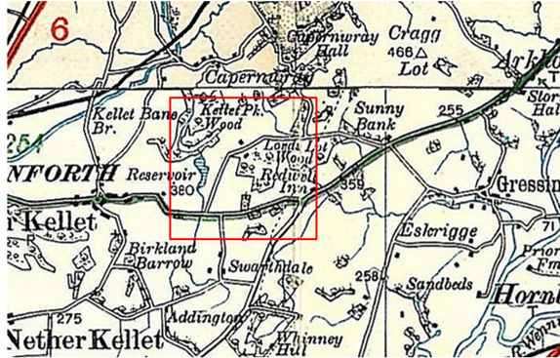
Observations |  | The map shows the full length of the amended route as a substantial through route and in the same manner as other public vehicular routes. There was no key provided with the map.
Investigating Officer's Comments |  | Although published by the Ministry of Transport the main significance of these maps was that they showed the early classification of public vehicular routes. The base map used by the Ministry of Transport was surveyed by the Ordnance Survey and shows that the route was not shown as a classified road *(A or B road).
1932 Rights of Way Map |  | The Rights of Way Act 1932 set out the mechanism by which public rights of way could be established by user and under which landowners could deposit maps to show highways already in existence and to indicate that they didn't intend to dedicate further rights of way. The Commons, Open Spaces and Footpath Preservation Society (which became the Open Spaces Society) who were the prime instigators of this Act and the later 1949 Act, called for local authorities to draw up maps of the public rights of way in existence (a quasi pre-cursor of the Definitive Map). This is set out in 'The Rights of Way Act, 1932. Its History and meaning' by Sir Lawrence Chubb [M]. The process for consultation and scrutiny followed in Lancashire is not recorded but some of the maps exist including maps for the following areas are available for inspection at County Hall: Lunesdale Rural District (RD), Lancaster RD, Burnley RD, Garstang RD and West Lancashire RD.
Observations |  | The County Council does not hold a copy of the map showing the area crossed by the application route.
Investigating Officer's Comments |  | No inference can be drawn with regards to the existence of public rights.
Aerial Photograph | 1940s | The earliest set of aerial photographs available was taken just after the Second World War in the 1940s and can be viewed on GIS. The clarity is generally very variable.
Observations |  | There is no aerial photograph for the area crossed by the application route available to view in the County Councils records.
Investigating Officer's Comments |  | No inference can be drawn.
6 inch OS Map  Sheet XXV.NW | Circa 1942 | 6 inch OS map revised 1910-11 and published circa 1942.
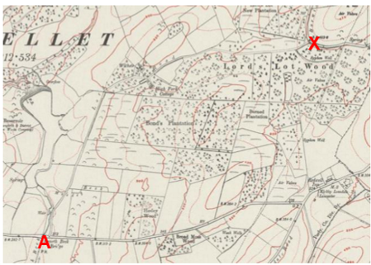

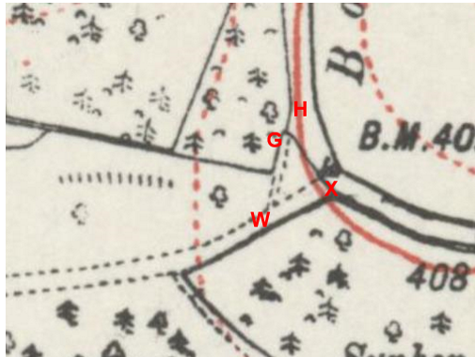
Observations |  | The application and amended route is shown in the same way as it is shown on the previous edition of the 6 inch OS map. Lines are still shown across the route at points D, G and X and two exit points are still shown leading from the route onto Borwick Road with the route to X, south of point H appearing to be the wider and more dominant/significant of the two exit points.
Investigating Officer's Comments |  | The application and amended route existed as a substantial named through route in 1910 and appeared capable of being used at least on horseback.
1 inch OS map  Sheet 89 – Lancaster and Kendal | 1947 | 1 inch map revised 1920 and published 1947.
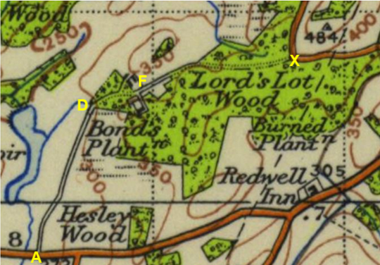
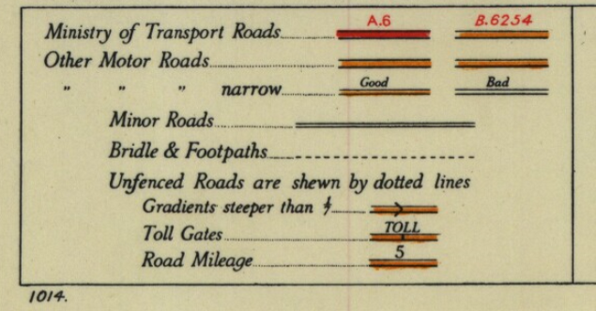
Observations |  | Further small-scale OS map showing the full length of the amended route, but not W-G of the application route. The route is shown depicted as a minor road with unenclosed sections between points D and F and point F and point X shown by dotted lines.
Investigating Officer's Comments |  | The amended route existed as a substantial through route in 1920 and appeared capable of being used on horseback and by vehicles, not necessarily by the public.
1:25,000 OS Map  Sheets 34/56 and 34/57 | 1947-48 | OS maps published 1947-48, date of revision not known.
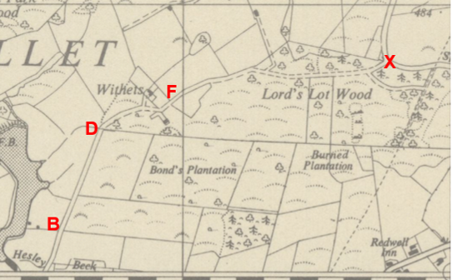
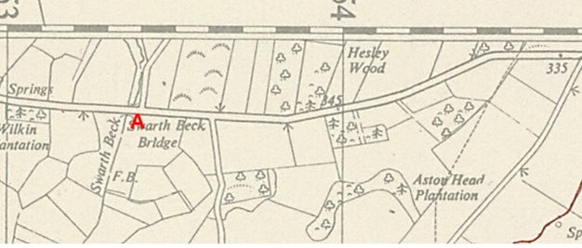
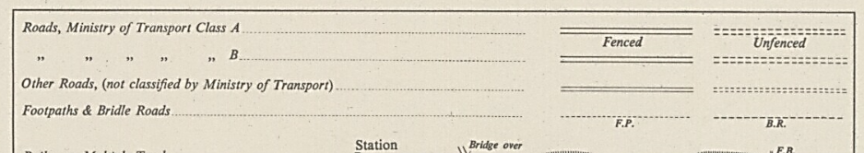
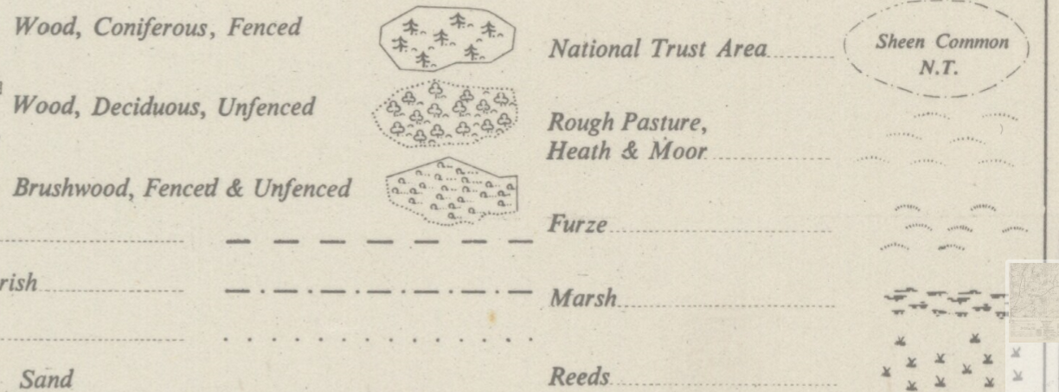
Observations |  | The full length of the amended route is shown as a through route but also providing access to properties between point D and point F. A line is shown across the route at point D but not where it exits onto Borwick Road at point X, where, as consistent with all small-scale maps examined only one exit point is shown onto Borwick Road.  Between point B and point D the land to the east of the application route is not shown as woodland but is shown as 'Furze' which meant that it was an area over which gorse bushes were found. The same is true of the area north of the application route as it approaches point X.  The route is depicted in the map key as 'Other Roads (not classified by the Ministry of Transport)' and not as a footpath or bridle road.
Investigating Officer's Comments |  | The amended route existed as a substantial through route and appeared capable of being used by vehicles but not necessarily public.
I inch OS map  Sheet 89 – Lancaster and Kendal | 1955 | 1 inch OS map revised 1950-51 and published 1955.
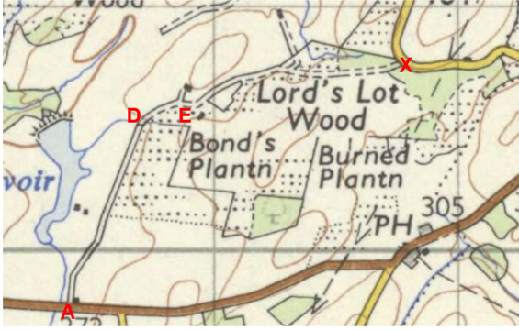
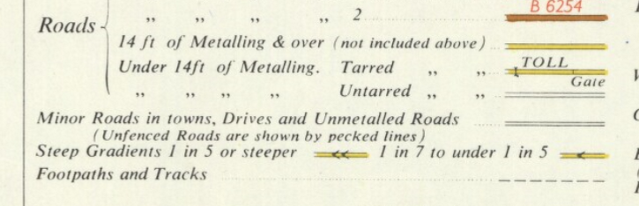
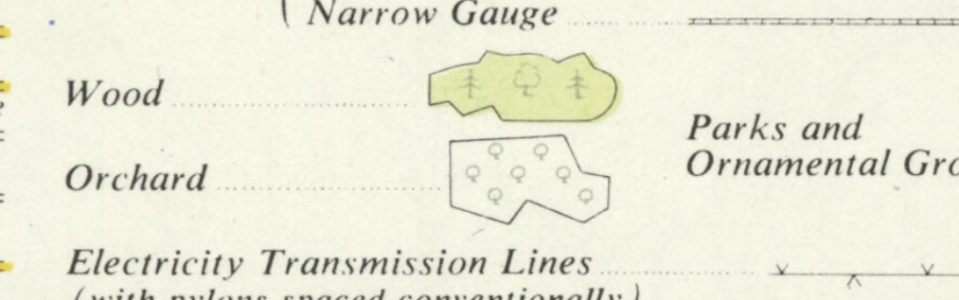
Observations |  | The full length of the amended route is again shown providing access to a number of unnamed buildings but also as a through route linking to two public vehicular routes. It appears to be depicted on the map as an unmetalled road unfenced along part of its length. Most of the woodland adjacent to the route and through which the route passes appears to have been felled with only small areas close to point X shown coloured green to indicate existing woodland.
Investigating Officer's Comments |  | The amended route existed as a substantial named through route in 1950s and appeared capable of being used by vehicles but not necessarily by the public.
1:25,000 OS sheet  SD57 and SD 56 | 1961-1965 | OS maps revised 1910-1911 with partial revision 1938-51 and major roads revised 1960, published 1961 and 1965.
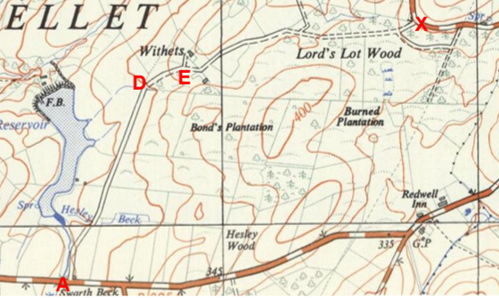
Observations |  | The full length of the amended route, but not the application route between W-H, is shown consistent with how it is shown on other OS maps examined.
Investigating Officer's Comments |  | The amended route existed as a substantial named through route and appeared capable of being used by vehicles but not necessarily by the public.
6 Inch OS Map  Sheets 56NW and 57SW | 1956 | The OS base map for the Definitive Map, First Review, was published in 1956 at a scale of 6 inches to 1 mile (1:10,560). This map was revised before 1930 and is probably based on the same survey as the 1930s 25-inch map.
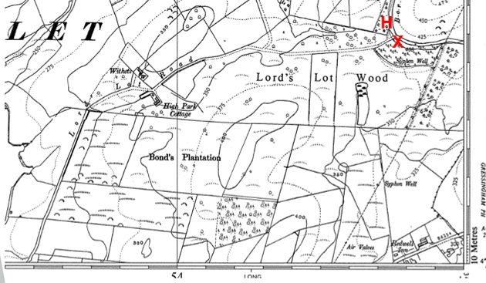
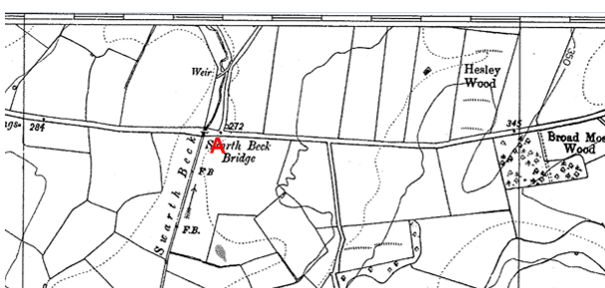

Observations |  | The full length of the application and amended route is shown as a named route consistent with how it is shown on earlier OS mapping.
Investigating Officer's Comments |  | The application and amended route existed as a substantial named through route in the 1930s (with section of the application route W-G as a lesser track) and appeared capable of being used at least on horseback.
1:2500 OS Map  SD5269-5369  SD5270-5370  SD5470-5570 | 1970 | Further edition of 25 inch map reconstituted from former County Series and revised in 1969 and published in 1970 as national grid series.
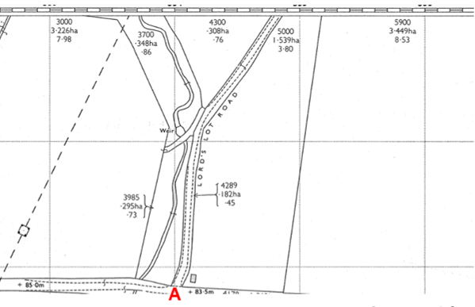
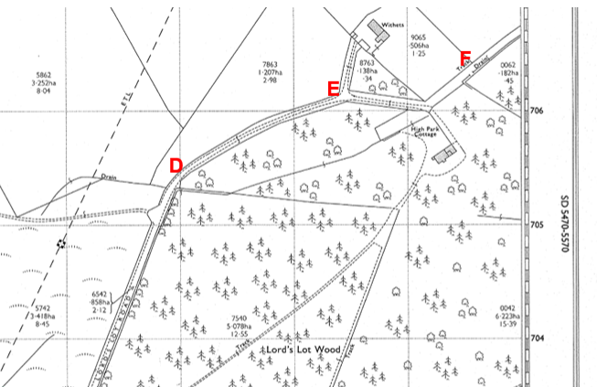
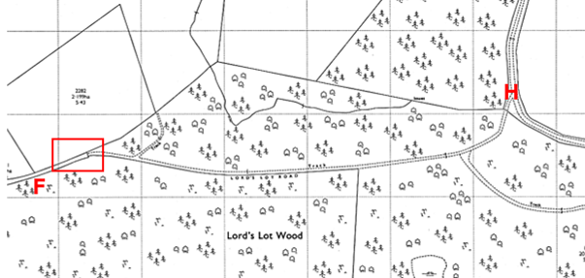
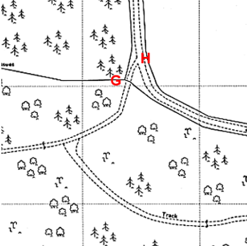
Observations |  | The full length of the application route, but not W-X of the amended route, is shown and is named on the map as Lord's Lot Road. The easterly section of the route passing through the wood is shown labelled as a 'track' and is narrower than the rest of the route. A line is shown across the route – most probably indicating the existence of a gate - at the entrance to the wood east north east of point F  At the eastern end of the route only one access point onto Borwick Road is shown whereas previously there had been two. A line is shown across the application route at point G consistent with the location of the metal barrier that exists at present and the only access onto Borwick Road is shown via the application route at point H.
Investigating Officer's Comments |  | The application route existed in 1969 and still appeared capable of being used. The section through the woodland to H appears to be less significant than in the past possibly indicating a decrease in use by vehicles along this section – possibly due to gates or barriers north east of point F and at point G.
Aerial photograph | 1960s | The black and white aerial photograph taken in the 1960s and available to view on GIS.
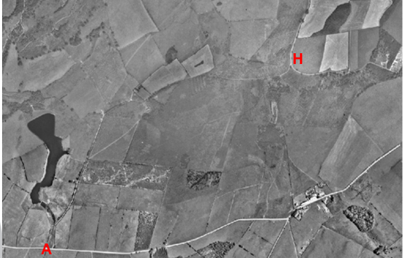
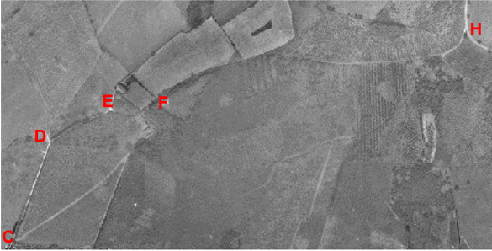
Observations |  | Most of the application route (but not the amended route between W-X) can be seen on the aerial photograph – particularly the section from point A to the properties located midway along the route between point E and point F. Much of the woodland shown on the OS maps is not very clear to see on the photograph suggesting perhaps that some had been felled and replanted.
Investigating Officer's Comments |  | The aerial photograph supports the existence of the application route in the 1960s.
Definitive Map Records |  | The National Parks and Access to the Countryside Act 1949 required the County Council to prepare a Definitive Map and Statement of Public Rights of Way.  Records were searched in the Lancashire Records Office to find any correspondence concerning the preparation of the Definitive Map in the early 1950s.
Parish Survey Map | 1950-1952 | The initial survey of public rights of way was carried out by the parish council in those areas formerly comprising a rural district council area and by an urban district or municipal borough council in their respective areas. Following completion of the survey the maps and schedules were submitted to the County Council. In the case of municipal boroughs and urban districts the map and schedule produced, was used, without alteration, as the Draft Map and Statement. In the case of parish council survey maps, the information contained therein was reproduced by the County Council on maps covering the whole of a rural district council area. Survey cards, often containing considerable detail exist for most parishes but not for unparished areas.
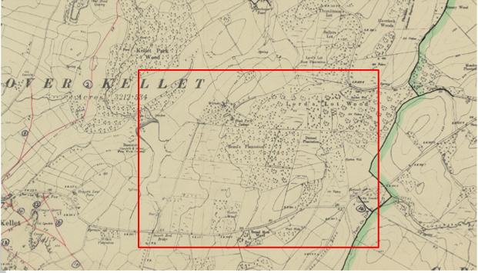
Observations |  | The route is not shown on the parish survey map.
Draft Map |  | The parish survey map and cards for Over Kellet were handed to Lancashire County Council who then considered the information and prepared the Draft Map and Statement.  The Draft Maps were given a “relevant date” (1st January 1953) and notice was published that the draft map for Lancashire had been prepared. The draft map was placed on deposit for a minimum period of 4 months on 1st January 1955 for the public, including landowners, to inspect them and report any omissions or other mistakes. Hearings were held into these objections, and recommendations made to accept or reject them on the evidence presented.
Observations |  | The route was not shown on the Draft Map of Public Rights of Way and no representations or objections were made relating to it.
Provisional Map |  | Once all representations relating to the publication of the draft map were resolved, the amended Draft Map became the Provisional Map which was published in 1960, and was available for 28 days for inspection. At this stage, only landowners, lessees and tenants could apply for amendments to the map, but the public could not. Objections by this stage had to be made to the Crown Court.
Observations |  | The route was not shown on the Provisional Map of Public Rights of Way and no representations or objections were made relating to it.
The First Definitive Map and Statement |  | The Provisional Map, as amended, was published as the Definitive Map in 1962.
Observations |  | The route was not shown on the First Definitive Map of Public Rights of Way.
Revised Definitive Map of Public Rights of Way (First Review) |  | Legislation required that the Definitive Map be reviewed, and legal changes such as diversion orders, extinguishment orders and creation orders be incorporated into a Definitive Map First Review. On 25th April 1975 (except in small areas of the County) the Revised Definitive Map of Public Rights of Way (First Review) was published with a relevant date of 1st September 1966. No further reviews of the Definitive Map have been carried out. However, since the coming into operation of the Wildlife and Countryside Act 1981, the Definitive Map has been subject to a continuous review process.
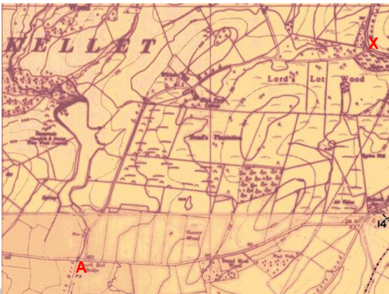
Observations |  | The route is not shown on the Definitive Map of Public Rights of Way (First Review) and from 1953 through to 1975 there is no indication that the application route was considered to carry a public right of way by the Surveying Authority. There were no objections or representations made regarding the route from the public when the maps were placed on deposit for inspection at any stage of the preparation of the Definitive Map.  However, in 1985 Nether Kellet Parish Council made an application under the provisions of the Wildlife and Countryside Act 1981 to record the route as a public bridleway. The application (File No. 804-39) was considered by the County Council's Public Rights of Way Sub Committee that same year. The site inspection detailed within the report made reference to locked gates which prevented unauthorised vehicular access through the woodland. It also made reference to the fact that it was possible to get round the gates on foot and on horseback and that there was evidence on site that the route was being used by people on foot and on horseback at that time. No user evidence however was submitted in support of the application. The Committee report detailed the map and documentary evidence considered; namely the inclusion of the route on Hennet's Map of 1830, the 6 inch Ordnance Survey map published in 1845 and the fact that it was also shown on later OS maps inspected. No other maps or documents appear to have been considered and the report concluded that officers considered that there was insufficient evidence to 'prove' that the route was an 'ancient highway'. The application was subsequently rejected.
Investigating Officer's Comments |  | The application or amended route was not recorded as a public right of way as part of the process of compiling the Definitive Map and Statement.  When an application was made to record it as a public bridleway the map and documentary evidence considered was very limited and the County Council concluded that it was insufficient to infer public status. However, this application was one of the first to be received and investigated by the County Council under the 1981 Act and this latest application was submitted with a great deal of additional evidence not previously considered and with a greater understanding of weighing evidence under the provisions of this legislation.
Highway Adoption Records including maps derived from the '1929 Handover Maps' | 1929 to present day | In 1929 the responsibility for district highways passed from rural district councils to the County Council. For the purposes of the transfer, public highway 'handover' maps were drawn up to identify all of the public highways within the county. These were based on existing Ordnance Survey maps and edited to mark those routes that were public. However, they suffered from several flaws – most particularly, if a right of way was not surfaced it was often not recorded.  A right of way marked on the map is good evidence but many public highways that existed both before and after the handover are not marked. In addition, the handover maps did not have the benefit of any sort of public consultation or scrutiny which may have picked up mistakes or omissions.  The County Council is now required to maintain, under section 31 of the Highways Act 1980, an up to date List of Streets showing which 'streets' are maintained at the public's expense. Whether a road is maintainable at public expense or not does not determine whether it is a highway or not.
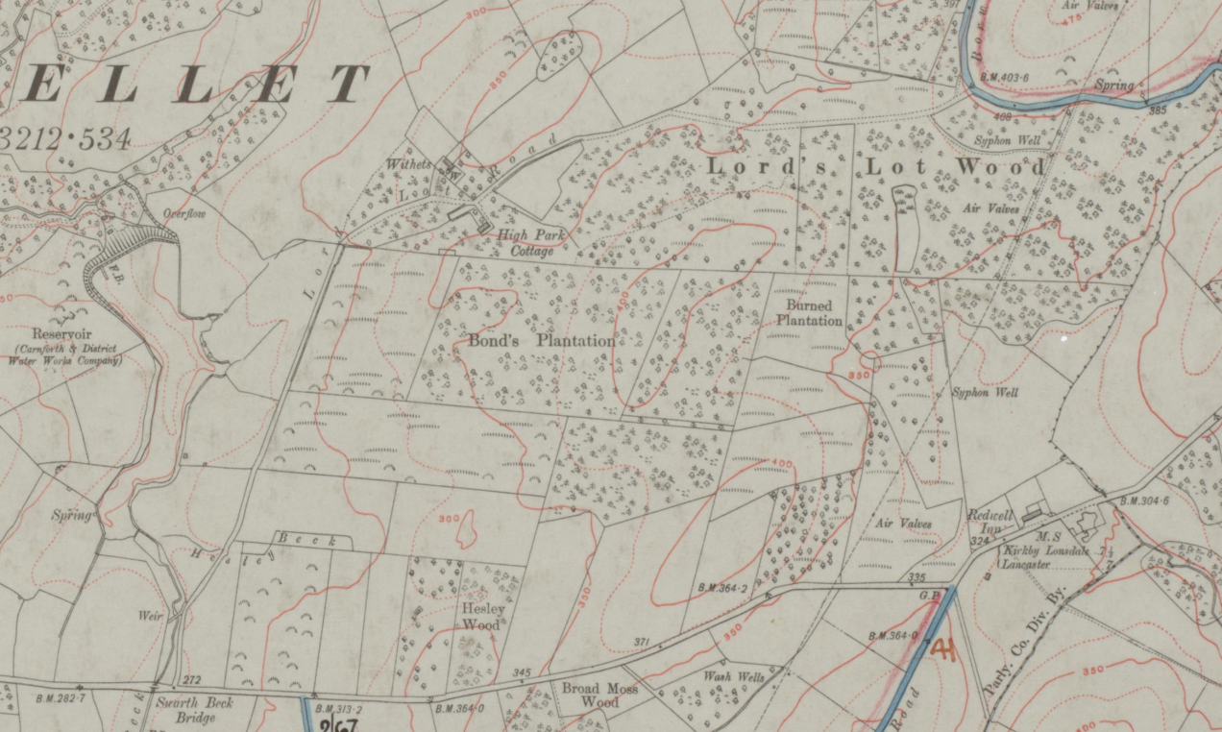

1929 Handover Map
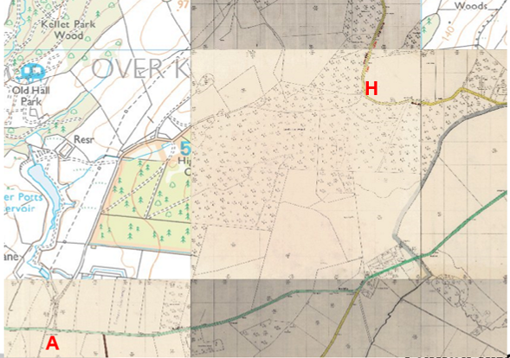
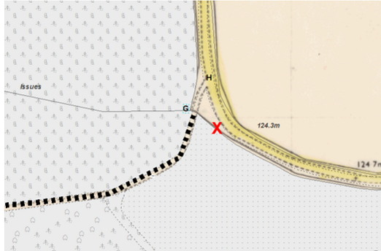
LCC highway plans
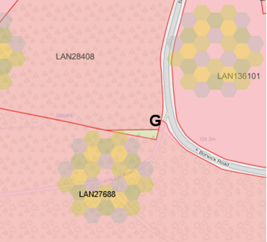
Extract from Land Registry Map Search
Observations |  | The application route is not recorded as a publicly maintainable highway on the county council's List of Streets and was not shown as a publicly maintainable highway in the records believed to be, or be derived from, the 1929 Handover Map.  The LCC highway maintenance plan shows the sealed surface of Borwick Road coloured to indicate public maintenance responsibility of the route. However, the OS plan clearly shows the boundary walls/fences along either side of the road suggesting that the application route between point G and point H is within the public highway known as Borwick Road. This is consistent with the land ownership records showing ownership of the land crossed by the application route up to point G.  The 1929 Handover Map shows the maintainable highway boundary to be in accord with the Land Registry boundaries except that the blue colouring does not appear to extend to the gate at G but to exclude that triangular area. This is consistent with usual practice.
Investigating Officer's Comments |  | The fact that the route is not recorded as a publicly maintainable highway does not mean that it does not carry public rights of access so no inference can be drawn.
Highway Stopping Up Orders | 1835 - 2014 | Details of diversion and stopping up orders made by the Justices of the Peace and later by the Magistrates Court are held at the County Records Office from 1835 through to the 1960s. Further records held at the County Records Office contain highway orders made by Districts and the County Council since that date.
Observations |  | No records relating to the stopping up, diverting or creating of public rights along the route were found.
Investigating Officer's Comments |  | If any unrecorded public rights exist along the route they do not appear to have been stopped up or diverted.
Statutory deposit and declaration made under section 31(6) Highways Act 1980 |  | The owner of land may at any time deposit with the County Council a map and statement indicating what (if any) ways over the land he admits to having been dedicated as highways. A statutory declaration may then be made by that landowner or by his successors in title within ten years from the date of the deposit (or within ten years from the date on which any previous declaration was last lodged) affording protection to a landowner against a claim being made for a public right of way on the basis of future use (always provided that there is no other evidence of an intention to dedicate a public right of way).  Depositing a map, statement and declaration does not take away any rights which have already been established through past use. However, depositing the documents will immediately fix a point at which any unacknowledged rights are brought into question. The onus will then be on anyone claiming that a right of way exists to demonstrate that it has already been established. Under deemed statutory dedication the 20 year period would thus be counted back from the date of the declaration (or from any earlier act that effectively brought the status of the route into question).
Observations |  | No Highways Act 1980 Section 31(6) deposits have been lodged with the county council for the area over which the application route runs.
Investigating Officer's Comments |  | There is no indication by the landowners under this provision of non-intention to dedicate public rights of way over this land.

The application route crosses land designated as access land under the Countryside and Rights of Way Act 2000 between point C and points G & X but does not cross any registered common land.

Summary

It is rare to find one single piece of map or documentary evidence which is strong enough to conclude that public rights exist and it is often the case that we need to examine a body of evidence, often spanning a substantial period of time, from which public rights can be inferred.

A previous application was considered by the County Council in 1985, not long after the 1981 Act introduced continuous review of the Definitive Map and Statement. This application was rejected. The current application is supported by much more evidence and the understanding of evidence for definitive map modification orders has developed considerably since 1985.

Taking the available map and documentary evidence as a whole, being shown since the mid-19th Century on a series of maps and documents it appears to the Investigating officer that on balance, the route should be recorded as a public bridleway but joining Borwick Road at point X not point H.

At the eastern end of the route it was noted that there appeared to have been two exit points onto Borwick Road with the earlier, wider and straighter of the two being to the south of the application route exiting onto Borwick Road approximately 25 metres south of point H (at point X). This route no longer physically exists with the only access now being via points G-H. The exit at point H is only shown on the Ordnance Survey maps which record physical existence but do not imply public rights and no modern user evidence has been submitted as part of the application. No evidence of the other – more prominent route being legally stopped up was found suggesting that it should be recorded as a public bridleway.

Head of Service – Legal and Democratic Services Observations

Landownership

Ownership of the land which the route crosses between points A and D and between points G and H is unregistered. Between points D and G and between points W and X the route crosses land owned by the Forestry Commission.

Information from the Applicant

The applicant submitted a number of maps and documents in support of their application. These are listed below and have all been considered by the Investigating Officer earlier in this report:

Greenwoods Map of Lancashire 1818
Hennet's Map of Lancashire 1830
6 inch OS maps published in 1847, 1894, 1916 and 1942
25 inch OS maps published in 1891 and 1913
1 inch OS maps published in 1898, 1947 and 1955
1:25,000 OS maps published in 1948 and 1952-63
Ministry of Transport ½ inch Road Map of Great Britain published 1922-23
Tithe Map 1847
Finance Act Map
LCC road status map
Land registry maps
Photographs of the route as it appears in 2020.

Information from Others

Cadent Gas responded to consultation stating that apparatus exists in the vicinity of the route and they thus objected pending further consultation.

United Utilities Water provided a consultation response confirming ownership of land adjacent to the route.

Councillor Williamson provided a consultation response noting the concerns of adjacent landowners. Councillor Williamson highlighted that the local reaction had been mixed because it is believed the road provides essential access to a local clay/game shoot and fishing lake as well as agricultural land surrounding the road. Whilst residents can see the benefits that might arise if LCC ended up with a maintenance role of the road if it was accepted as a bridleway, there is equal concern that adoption of this track as a bridleway would prohibit essential vehicular access for the agricultural businesses which surround the track and for the regular visitors to the commercial shoot and fishing lake.

A member of the public contacted the council to object to the application on the basis that the route should be recorded as a Byway Open To All Traffic stating that on early maps the road is clearly substantial enough to have been recorded as a route of some significance and this would suggest it was used by far more than just pedestrians. In support of this view he provided extracts of the 1 inch OS map published in 1898 and 6 inch OS map published circa 1942 both of which have been reproduced and considered earlier in the report.

Information from the Landowner

The Forestry Commission did not provide a response to our consultation.

A consultation response was received from several adjacent landowners confirming the land in their ownership and objecting to the application. The grounds of their objections were that they believe the road to be a private road for private vehicular access, shooting in the vicinity of the route which may prove a safety concern, particularly highlighting the unpredictability of horses around the sound of guns, safety of the public mixing with the private vehicular traffic and that the historical map evidence simply shows a private access road for extracting timber, rather than a public right of way.

Assessment of the Evidence

The Law - See Annex 'A'

In Support of Making an Order(s):

- Volume of map and other documentary evidence supporting the existence of a long-standing physical way which could have been used at least on horseback.
- Finance Act records supportive of public status.

Against Making an Order(s):

- Some suggestion of the route, at least initially, being a private road.

Summary

No modern or historical public user evidence has been submitted so in these circumstances a presumption of dedication of a public right of way under section 31 cannot be relied upon. It is therefore necessary for Committee to consider whether the map and/or documentary evidence is sufficient to support the dedication of a public right of way under common law.

The cumulative evidence suggests that historically a way existed over the full length of the amended route, from A to X, connecting two public vehicular highways. The key issue is whether it carried any public rights and, if so, the nature of those rights.

The Inclosure Award map (1805) indicates that part of the route (between A to C) was a private road providing direct access to a property. No through route to point H or X is depicted. This map demonstrates that at least part of the route existed in 1805 and was probably capable of accommodating vehicular traffic (which would have been horse and cart at that time), albeit it was likely to be of a private nature.

Greenwood's Map published in 1818 only depicts part of the route (from point H or X to a point that possibly corresponds with point C) and no inference can be drawn regarding its status as the key explained that the map showed private as well as public roads.

The first time a through route from Kirby Lonsdale Road to Borwick Road is visible in a single document is on Hennet's Map (1830). This depicts it as a "cross road" from point A through to X. The fact that the amended route is shown as a through route may be suggestive of it existing as a substantial route in 1830 and being considered by Hennet as a public carriageway but it was noted that the route was drawn to be narrower than other routes shown as cross roads on the map.

The route was similarly shown on the Cassini Map (1840s) which was derived from the first edition 6 inch OS maps and lends support to the fact that the route existed as a substantial route suitable for traffic besides on foot or horseback.

The Tithe Map and Award (1847) shows the route existed as a substantial through route providing access to a number of properties which would have accommodated equestrian and vehicular traffic at that time. The Tithe Award describes the route as a "lane" in private ownership. This contrasts with other nearby roads which are now recorded as public vehicular carriageways and which were described as being roads in the Township of Over Kellett.

The first 25 inch OS Map (surveyed in 1891) shows the full length of the application and amended route as a through route (named "Lord's Lot Road") connecting two recognised vehicular highways from points A to H & X but it is distinguishable from those highways (which were shown as being in 'good repair') by the manner in which it is depicted. This could suggest it was of inferior status and/or condition and not considered to be part of the public carriageway network. Yet it must have been considered significant enough to be named, although private roads can be named too. The possible presence of gates then shown across the route by the OS is not inconsistent with a public route in a rural area and the route is depicted in such a way that it appears to have been capable of being used on horseback.

The Finance Act records are inconsistent but do appear supportive of the route's public status by 1910. The exclusion of section A to D from the adjacent taxable parcels of land raises the question as to whether this part of the route was regarded as a public highway carrying vehicular rights but it is also noted that ownership of this part of the route is unregistered and unknown. Beyond point D the route is recorded in private ownership and is not excluded. A large deduction was claimed for an unspecified public right of way and it is normally the case that such deductions referred to an acknowledged existence of footpath or bridleway rights.

Some of the objectors claim that the route exists as a private access road only. Committee is advised that the existence of any private rights of access over the route is not necessarily to the exclusion of any public rights that may subsist.

In conclusion, there is no single document which offers irrefutable evidence in its own right to determine this application. Collectively, there is a large body of evidence which supports the physical existence of the amended route from points A to X from at least 1830 and of it being capable of being used on foot, horseback and possibly by vehicle. The evidence suggests that initially the route was a private lane but that over the course of time public rights came into existence. Although the Finance Act records could be suggestive of public vehicular rights over part of the route, the majority of the documentary evidence inspected from before and since provides little support for the existence of public vehicular rights of way along the entire route. The evidence is however supportive of public bridleway rights.

Officers believe that the oldest depiction of the route shows it exiting onto Borwick Road at point X and that this exit point remained the most prominent until around the 1960s when it disappeared and the only exit was then at point H (as evidenced by aerial photographs and OS mapping).

Committee is advised that, on balance, there is sufficient evidence from which a dedication of a public bridleway between points A-W-X can be inferred at common law but not between points W-H. Committee may therefore consider making an Order to add a public bridleway to the Definitive Map and Statement accordingly and promoting the Order to confirmation.

Risk management

Consideration has been given to the risk management implications associated with this claim. The Committee is advised that the decision taken must be based solely on the evidence contained within the report, and on the guidance contained both in the report and within Annex 'A' included in the Agenda Papers. Provided any decision is taken strictly in accordance with the above then there is no significant risks associated with the decision making process.

Alternative options to be considered -

- to reject the application and not make an Order.
- to make an Order recording a public bridleway between points W-H in addition to points A-W-X.

Local Government (Access to Information) Act 1985

List of Background Papers

Paper | Date | Contact/Directorate/Tel
All documents on File Ref: 804-642 |  | Simon Moore, 01772 531280, County Secretary and Solicitors Group
Reason for inclusion in Part II, if appropriate

N/A

The Ordnance Survey (OS) has produced topographic maps at different scales (historically one inch to one mile, six inches to one mile and 1:2500 scale which is approximately 25 inches to one mile). Ordnance Survey mapping began in Lancashire in the late 1830s with the 6-inch maps being published in the 1840s. The large scale 25-inch maps which were first published in the 1890s provide good evidence of the position of routes at the time of survey and of the position of buildings and other structures. They generally do not provide evidence of the legal status of routes, and carry a disclaimer that the depiction of a path or track is no evidence of the existence of a public right of way.
Aerial photographs can show the existence of paths and tracks, especially across open areas, and changes to buildings and field boundaries for example. Sometimes it is not possible to enlarge the photos and retain their clarity, and there can also be problems with trees and shadows obscuring relevant features.

